**Project 3**

## Imports

from itertools import chain

import string

from collections import Counter

import pandas as pd

import requests

from nltk.tokenize import word_tokenize

from nltk.corpus import stopwords

from nltk.stem import WordNetLemmatizer

import json

import requests

import json

**Questions 1**

##Make Request

def get_aspirin_info(record_number):

base_url = "https://pubchem.ncbi.nlm.nih.gov/rest/pug_view/data/compound"

compound_url = f"{base_url}/{record_number}/json"

response = requests.get(compound_url)

if response.status_code == 200:

return response.json()

else:

return {"error": f"Failed to retrieve information for record number {record_number}"}

# Example usage:

aspirin_info = get_aspirin_info(2244)

print(json.dumps(aspirin_info, indent=2))

**Question 2**

## Set list and create dataframe

aspirin_refs: list[dict] = aspirin_info['Record'] ['Reference']

aspirin_df = pd.DataFrame(aspirin_refs)

print(aspirin_df)

aspirin_df.head()

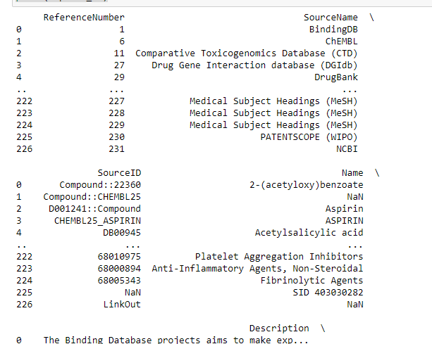

**Question 3**

##Prepping text and tokenizing

text: str = aspirin_df ["Description"].str.cat(sep= " ")

tokens: list[str] = word_tokenize(text)

tokens_lc: list[str] = [token.lower() for token in tokens if token not in string.punctuation]

wnl = WordNetLemmatizer()

tokens_lc_nostop_lemmatized: list[str] = [t for t in tokens_lc if t not in stopwords.words('english')]

bag_of_words: Counter = Counter(tokens_lc_nostop_lemmatized)

**Question 4**

bag_of_words.most_common(10)

